**Shabbos Stories For**

**parshas ki sisa/Purim 5785**

Volume 16, Issue 25 15 Adar 5785/March 15, 2025

**Printed L’illuy nishmas Nechama bas R’ Noach, a”h**

For a free subscription, please forward your request to ***keren18@juno.com***

***Past emails can be found on the website – ShabbosStories.com***

**The Reward for Not**

**Breaking the Engagement**

**By Rabbi David Ashear**

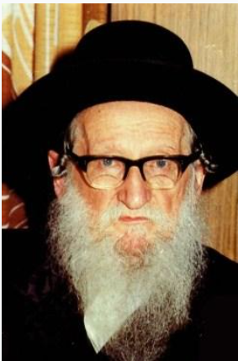

R’ Yitzchok Weiss was of the great recent Gedolei HaPoskim who served as a Dayan, and authored the famed work Minchas Yitzchok. He passed away in 1989 at the age of 87. When R’ Weiss was poised to get engaged, his mother became aware that the girl had certain physical blemishes and told her son the shidduch was not for him.

The young R’ Weiss said to his mother, “If I end it now, it will embarrass her. I don’t want to do that to another person. Let’s move forward.” R’ Weiss married her and they had one child together named R’ Berish, who eventually became the Rosh HaKahal of the Satmar community in Manchester, England.

He [Rabbi Yitzchok Weiss] passed away in 2020 at the age of ninety. From this one child, R’ Yitzchok Weiss had hundreds of grandchildren and great-grandchildren, many of whom are outstanding talmidei chachomim. R’ Yitzchok lost his young wife in the Holocaust and, although he remarried, he never had another child. He discovered he was not able to have children, but in the merit that he married his first wife and refused to do something that would embarrass her, Hashem changed the course of his destiny and blessed him with a child, and generations of children after him. (Living Emunah on Shidduchim)

*Reprinted from the Parshas Emor 5784 email of The Weekly Vort.*

**It’s All About**

**Serving Hashem**

**By Aharon Spetner**

It was Purim morning in the Jerusalem Prison and all of the inmates had spiced up their prisoner’s uniforms in celebration of the festive day. They had just heard krias Megillah and had finished davening, and Rav Volender, the prison rov, was giving his daily Mesillas Yesharim shiur.

“So, you see, the Ramchal is saying that it’s important not to be the type of person who is always looking to relax,” said Rav Volender. “Because, such a person...

**The Sound of Singing Coming from**

**Outside the Prison Beis Midrash**

Rav Volender’s voice trailed off at the raucous sound of singing coming from outside the prison beis midrash.

“Excuse me, can you please keep it down? We’re in the middle of a shiur here... Tzadok? What are you doing? Why aren’t you attending my shiur? And where did you get that cat? And why are you dancing with a cat in the middle of the prison? Are you drunk? How did you get wine in the prison? And how on earth did you manage to lose half of your beard yet again?”

“Purim Someiach, kavod harav!” Tzadok “Hatzadik” said, still dancing, a ragged-looking cat in one hand and a cup full of purple liquid in the other. “This isn’t wine - it’s grape-flavored petel! And this isn’t a cat - it’s Eliyahu Hanavi!”

“Wait, what?” Rav Volender asked, bewildered.

**The Malach Gave Eliyahu Hanavi a Cake**

“Yes, I found this cat in the prison yard last night and I could tell that it was no ordinary cat. He was eating a piece of cake - and I remembered that you told me the story about how a malach gave Eliyahu Hanavi a cake after the story of Har Hakarmel so I immediately knew that this cat must be the holy prophet Eliyahu!”

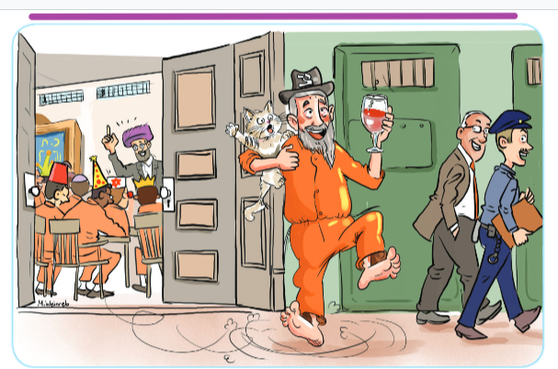

**Illustrated by Miri Weinreb**

“Tzadok,” warned Rav Volender. “If the guards see you with that cat you’re going to be in a lot of trouble.”

“Kavod harav,” Tzadok said. “The guards are not religious. So they won’t be able to see Eliyahu Hanavi.”

**Only Half a Beard Again**

“And why are you missing half of your beard again?” Rav Volender repeated.

“Oh, Eliyahu Hanavi scratched my face when I picked him up and took off part of my beard. Hashem must have told him to do that. Vina-vina-vinahapoch Adar, visimcha visasson zachor latov!” Tzadok resumed singing and dancing, holding the frightened cat tightly so it couldn’t escape.

“Tzadok, Tzadok,” Rav Volender said, but Tzadok did not appear to hear.

“TZADOK!” Rav Volender bellowed.

Tzadok paused his dancing.

“Kavod harav,” he said. “I need to sing to Eliyahu Hanavi because he looks so sad and you taught me that a navi needs to be happy in order to get a nevuah.”

“Tzadok,” said Rav Volender, ignoring this last statement. “Why didn’t you come to my Mesillas Yesharim shiur today?”

**No Time to Learn Torah on Purim**

“Rebbe, it’s Purim!” Tzadok said. “Who has time to learn today? We need to be singing and dancing all day!”

“Well, Tzadok, it is true that it is extremely important to sing and dance on Purim and not to sit around glumly. And of course there are the mitzvos hayom. But the most important mitzvah of the day of Purim is to learn Torah!”

“It is?” asked Tzadok. “More important than eating hamanfish?”

“Hamanfish?” Rav Volender asked, confused.

“Yes, don’t you remember? It’s the new mitzvah I invented where you have to eat a triangle shaped tunafish sandwich on Purim to remember the rotten fish that Haman’s daughter dumped on her father’s head.”

“Tzadok, you can’t invent a mitzvah. And where does it say that she dumped fish on Haman’s head?”

“I say it,” Tzadok said proudly. “She dumped smelly garbage from the window. It probably smelled because there was old smelly fish in it.”

“Tzadok,” Rav Volender said. “We’re getting way off topic here. The important thing I am trying to tell you is that Purim isn’t just a day of fun. It is a day of avodas Hashem. And therefore, we must start it off in the right way, by spending time learning Torah. And by doing so, we demonstrate that all of the exciting and fun things we do today are also part of Avodas Hashem.”

“Oh, so is that why children everywhere have Yeshivas Mordechai Hatzadik, where they all come to learn in shul on Purim?”

“Of course, why else?”

“Oh, I thought they just do it for the treats and prizes,” Tzadok said. “And you weren’t giving out any treats or prizes so I didn’t come.”

“No, no, Tzadok. We don’t learn for the treats and prizes. We learn because this is what Hashem wants us to do. Now why don’t you join my shiur? We still have ten minutes left.”

**Have a Preilichen Furim**

**and a Shonderful Wabbos!**

*Reprinted from the Parshas Tetzaveh 5785 email of Toras Avigdor Junior, based on the Torah teachings of Rabbi Avigdor Miller, zt”l.*

**The Purim Question**

**By Shlomo Borger**

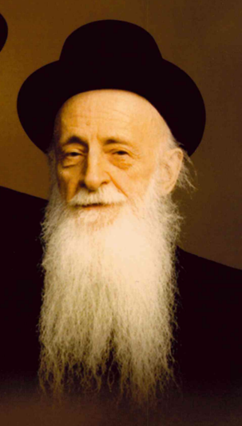

A little background first. My mother-in-law a"h was the sister of Rebbetzin Malka Kalmanowitz a"h, the wife of Mirrer Rosh Yeshiva Rav Shraga Moshe zt"l.

On Purim, the Rosh Yeshiva would sit at the dining room table and bochrim would come through the front door to bring him mishloach manos.

Being family, I would come through the family entrance (the side door) that leads to the kitchen. There, I would leave my young daughters with their great-aunt, while I'd go see the Rosh Yeshiva.

One year, totally out of the blue, he asked me when I'll be promoted. (I am a retired actuary.)

I replied that I have no knowledge of an upcoming promotion, and he dropped the subject. When I came to work the next day, I received word that I was promoted the previous day at around the same time as the Rosh Yeshiva brought up the subject.

Days later when I met the Rosh Yeshiva, I informed him about my promotion and said that he has Ruach haKodesh [ type of prophecy]. He just smiled without confirming it.

*Specially written for the Shabbos Stories for Parshas Ki Sisa 5785.*

**The Wrestling Challenge**

**By Rabbi Shmuel Choueka**



**Rav Elimelech Biderman**

Rav Elimelech Biderman tells a story of a group of teenagers who were at a Torah class, when a wealthy man stepped up to the podium and announced, “I would like to give money to everyone who came to the class tonight. This is how the money will be distributed: Everyone should take a partner to arm-wrestle with. Keep track of how many times you win, because for each time you win, I will give you one dollar.”

After a little while, the man went to each pair and asked them their score. By one team, one of the teenagers won three times and the other won four times. By another team, one boy won six times and the other won only twice. Each boy was given a dollar for every time he won.

Then the man came to a pair who told him, “We each won 500 times.” And the man gave them each $500.

The man then went back to the podium and said, “You were all trying to win against your opponent so you wasted a lot of time and energy battling one another. But these two boys were trying to help one another, so first one of them let the other win over and over, and then the other did the same for him. Because of that, they each got $500.”

On this holiday of Purim, we should reflect on our relationships with others and try harder to bring joy to our friends and family members. The special misvot of Purim focus on our interactions with others and our ability to help them and bring them happiness. But this is not just a one-day event. This should be a reminder for us to always go out of our way to understand and attend to the needs of others and to help them in any way that we can. Hashem will then act in kind and send us tremendous berachah. May this be the catalyst that will bring the ultimate redemption and the coming of Mashiah speedily and in our days, Amen.

*Reprinted from the Parashat Vayikra-Zachor 5784 email of Rabbi David Bibi’s Shabbat Shalom from Cyberspace.*

**Mistaken Burial**

**From the Desk of Yerachmiel Tilles**

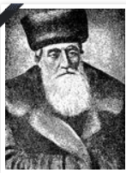

**Rabbi Eliyahu-Chaim Meisel**

An epidemic struck the town Lodz, taking many lives. The municipal health authorities determined that the crowded living conditions in town were largely responsible, so they passed edicts limiting migration into the city as a preventive measure. Couples with children were among those forbidden to take up residence there.

It happened that a family was forced by economic necessity to move specifically to Lodz and to circumvent the law, They filed a form with the city describing themselves as a single mother with her brother, rather than a couple with children. Unfortunately, the wife was stricken with the plague and soon succumbed.

When the women from the Chevra Kadisha (burial society) came to the house to do the tahara (ritual purification) they were shocked to discover the bereaved children running to their supposed uncle with cries of "Tatty, Tatty!" (Daddy, Daddy). Not knowing what to think, they reported the situation to the chevra kaddisha.

Those in charge had very little time to decide what to do. The law required plague victims to be buried within the hour. Under pressure, with no time to investigate, they concluded that the couple must have been brother and sister who had married, chas veshalom (Heaven forbid) and thus they decided to bury the wife outside the cemetery, in the area reserved for apostates and the like.

The following night the woman came to her husband in a dream crying, screaming and wailing about what had been done to her, for she was being tormented in the next world as a result. The husband did not wish to take such a dream seriously, but the following night his wife returned, and again every night subsequently. Besides describing her intense suffering, she mentioned that she had passed every judgment in the World to Come and was being punished exclusively as a result of her grave having been misplaced.

After the shiva (the week of mourning), the widower went to the chevra kaddisha to ask them to rectify the mistake. The stood by their decision, however, claiming that they could only work according to the official documents. The widower threatened to take them to a din Torah (trial according to Jewish law), which they agreed to quite willingly, and so Rabbi Eliyahu-Chaim Meisel entered the picture.

The Rav heard out both sides and decided immediately in favor of the husband, whose honesty was patently obvious to him. The chevra Kaddisha had a problem with this decision, though. As much as they were happy to assign a new, worthy spot for the body of the deceased, especially since she had now been discovered to have been a righteous person, having passed through the beit din shel mala (Heavenly court) without harm, disinterring her body was impossible.

Touching the bodies of the plague victims more that absolutely necessary to bury them, was against the law. If the widower was willing to take the risk, though, and transfer the body himself, they were more than ready to accommodate him.

Rabbi Eliyahu Chaim thought the matter over and decided that the husband must do no such thing. The risk to his health and liberty were too great, and the woman would have to remain where she was. Still, something would have to be done for her suffering soul and Rav Meisel undertook to recite mishnayot for her neshama (soul) himself. What good this would do, the widower was not equipped to understand, unfortunately, and he left the beis din bitterly disappointed.

A few days later, though, the husband was seen glowing with joy, which he took great pleasure to explain. His wife had come to him once more in a dream and had reported the wonderful result of Reb Chaim's efforts.

"You have no idea what kind of Rav you have!" she told him, "Ever since he started to learn mishnayot, it is as if an iron fence has come down and separated me from the other graves outside the cemetery. Ever since, I have had peace."

With that, she took her leave from her husband, explaining that she would no longer be permitted to visit him, since such visitations were allowed only for reasons of extreme urgency.

**Source:** Adapted by Yerachmiel Tilles from a recorded telling by Rabbi Yisrael Grossman, Rosh Yeshivat Pinsk-Karlin, which he heard from Rav NachumYosef Wilhelm z"l, who was eyewitness to the entire incident.

**Biographic note:** Rabbi Eliyahu-Chaim Meisel (1821-1912) served as the Rabbi of Horodok, where he was born, at a young age, from 1840 to 1843. From 1873 he was the Chief Rabbi of Lodz until his death at age 91. He was known for his great concern and care for the social- economical predicament of his people. Stories abound spotlighting his exceptional cleverness in problem-solving.[for example] A Yiddish book was written about him in 1925.

*Reprinted from the Parashat Tetzaveh 5785 email of KabbalaOnline.org, a project of Ascent of Safat in Israel.*

**Honor and Glory**

Though garments are important, we also learn that materialistic things mean nothing, and that true value comes from within. There is a story about a man invited to a fancy party. This man was not incredibly sophisticated and was not used to wearing elegant clothing. He came to the party wearing a nice but very informal outfit.

When he arrived at the party, he was stopped by the guards at the entrance who told him that he could not enter the building because of his “inappropriate clothing.” The man wasn’t upset, and he went back to his house to put on the best suit he owned, and he returned to the party, where he was then let in without any problems.

During the party, when they all sat for a seated dinner, the man suddenly stood up, lifted his plate with the most exquisite catered food, and poured it all over himself, effectively ruining his nice suit. His friends at the table asked him why he did such a thing and he told them, “Since I was not invited but my suit was, I thought it was logical to give it the food.”

*Reprinted from Parashat Tetzaveh 5785 email of Jack E. Rahmey based on the Torah teachings of Rabbi Amram Sananes.*

**The Original Telehealth**

**As told by Rabbi Menashe Althaus**

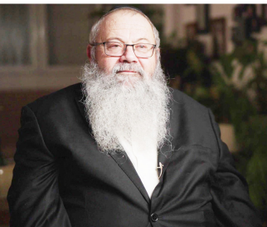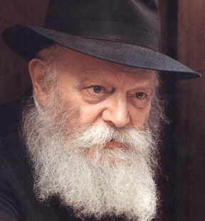

**Rabbi Menashe Althaus and the Lubavitcher Rebbe**

Towards the end of 1980, I traveled to New York with a group of friends, as part of the *kvutza*program, in which graduates of Chabad *yeshivot*in Israel spend a year with the Rebbe, studying at 770.

Chabad students usually spend their Fridays on Jewish outreach, going out to help people put on *tefillin*or to distribute Shabbat candles, and that year I was hoping to do the same. After speaking to Rabbi Shraga Zalmanov, head of the Lubavitch Youth Organization’s Hebrew-speaking division, I found out that he would be visiting the local Israeli consulate on Sukkot – but nobody went there on a weekly basis. When I asked to come along, he happily agreed.

The following Friday, I returned on my own. I didn’t know whether I would be allowed in the building, which housed Israel’s diplomatic delegation to the United Nations, but I gave it a shot.

At the entrance, I rang the intercom.

“Who are you?” a voice inquired.

“Menashe from Chabad,” I answered. “I was here on Sukkot. Now I’ve come to offer *tefillin*to whoever is interested.” The door opened.

Within a month, I became a regular at the consulate. The security guards would open the door as soon as they saw me, and then come out to greet me with a warm hug.

One Friday, a security officer handed me a note with the phone number and address of a Manhattan hospital. “Yisrael Granot is there, and he’s not doing well. He needs a serious operation on his spine.”

Yisrael Granot was the head of consular security, and as the officer knew, I had a special connection with him. In addition to putting on *tefillin*whenever I came, he would also take a few moments to study an idea from the weekly Torah reading with me.

Like most Fridays, I got back to 770 with only minutes to spare before Shabbat candle-lighting, so I was unable to call then. But I was at the public telephone immediately after Shabbat.

Yisrael’s ailing voice soon came on the line. Groaning in pain, he explained to me that he had been injured on the job. Based on their medical imaging, the doctors had decided that he needed surgery.

But he had a request for me. “I once escorted a certain prominent Israeli figure on a visit to the Rebbe, as a member of his security detail. I didn’t understand everything the Rebbe said then, but I believe that his blessing could help me now. Please ask the Rebbe for a blessing for my recovery.”

I wrote down his and his mother’s full Hebrew names. “The Rebbe isn’t in his office now,” I told him, “but the moment that his secretariat opens up tomorrow, I will submit your request for the Rebbe’s blessing.”

A phone call wasn’t enough, so I set out to visit Yisrael in the hospital. In the ‘80s, taking the subway late at night could be dangerous, but I managed to convince a friend to come along. Sitting on the train, we were surrounded by various dubious characters under the influence of alcohol or drugs, but thank G-d we arrived safely.

Given how he had sounded on the phone an hour-and-a-half earlier, I was surprised to find Yisrael looking cheerful in his hospital bed. Noticing the look on my face, Yisrael explained:

“You might not believe this, and I’m not sure I believe it myself. But, as soon as I hung up the phone after our conversation about getting a blessing from the Rebbe, all of my pain disappeared!”

As promised, I delivered my note to the Rebbe the next morning. Later that day, Rabbi Binyomin Klein, one of the Rebbe’s secretaries, informed me that the Rebbe had said he would mention Yisrael in prayer at the resting place of the Previous Rebbe.

When I called Yisrael to update him, he became very emotional: “This righteous *tzaddik* is fasting and praying for me? He doesn’t even know me!” He burst into tears.

The next Friday, as I arrived at the consulate, I found Yisrael back at his job. “As I put it to the doctor,” he told me “with all due respect to the X-rays, I came to the hospital because I was in pain. Now that the pain has gone, I’m going home.” He handed me a letter addressed to the Rebbe, expressing thanks for his recovery, and asking what he could do for the Rebbe. I delivered it that Sunday.

The next day, Rabbi Binyomin Klein told me that the Rebbe had a mission for me. “Bring these to Yisrael Granot,” he instructed, handing me a letter and a pair of *tefillin*.

In the letter, the Rebbe asked Yisrael to put on the *tefillin* regularly, and to take care to only have kosher food and drink – both inside and outside the home. Yisrael began putting on *tefillin*by himself from then on. But I continued to visit and study with him every week.

When Yisrael concluded his stint in the consulate that summer, I invited him – with the help of Rabbi Klein – for a personal audience with the Rebbe.

“How does one go to the Rebbe?” he asked me.

“The Rebbe is like a father,” I told him. “Speak freely, and say what’s on your mind.”

But that wasn’t enough for him. “I want to go like a *chasid*,” he insisted.

I explained that our custom was to prepare any questions or requests for the Rebbe on a note. “Then, if the Rebbe has questions for you, he will ask, and you answer.”

Yisrael and his wife, Varda, came to 770 with a note they had prepared. They were hoping to receive a blessing for their only son, who had just celebrated his Bar Mitzvah; for Yisrael, who was going to transition to a civilian career; and for Varda, who was hoping to become a teacher in a school in Petach Tikvah. They did not, however, ask to be blessed with more children, as they had been told that they were not medically capable of doing so.

However, when the Rebbe responded to their note, he included – twice – an additional blessing for a “larger family.” Yisrael and Varda knew that they could not have any more children, and so they hadn’t even thought to mention it. Now, standing in Rebbe’s room, they barely noticed the extra blessing.

When I returned to Israel myself, a few months later, I found a letter from Yisrael. He reported that all of the Rebbe’s blessings had been fulfilled: He found a job to his liking, Varda had been accepted as a teacher, and their son was doing well at school.

He wrote that Varda had recently had a health scare in a suspected case of uterine cancer. But after a proper examination, her doctor had told them that she had “come down with a very healthy kind of illness.” She was pregnant! Looking back, they made the connection to that unsolicited blessing from the Rebbe.

They named their daughter Meirav, which can be translated as “from the rabbi.” She grew up to be an outstanding student and then an officer in the IDF. Later, I had the honor of serving as a witness at her wedding.

At the wedding, Yisrael told me through tears, “When the Rebbe gave us that blessing, we didn’t know what he was talking about!”

*Rabbi Menashe Althaus is the director of Chabad in Kiryat Tivon, Israel. He was interviewed in February of 2024.*

*Reprinted from the Parshat Terumah 5785 edition of “Here’s My Story [with the Lubavitcher Rebbe], a publication of JEM (Jewish Educational Media.)*

**The One Hundred Dollar Bill**

Rav Shimon Finkelman related a story. For many years, the Sadovner Rav, Rav Yisrael Sekula, zt”l, would spend his Purim morning in an unusual way. He would daven Shacharis and hear the Megilah at an early Minyan. He would then spend the rest of his morning walking around Boro Park and visiting all the Shuls, and collecting Tzedakah for the poor.

One year, he arrived home from his collections shortly before noon. He was exhausted, but exhilarated. It was Rav Sekula’s custom to partake of two Seudos on Purim day, and the table was already set for his first meal. However, Rav Sekula’s pockets were bursting with assorted change and bills from all the Tzedakah he had collected.

He emptied his pockets and his children helped him unfold and sort out the money. Suddenly, Rav Sekula cried out in dismay, “Look! A one-hundred-dollar bill!” Rav Sekula knew that many people collected money in Boro Park on Purim morning, and it was highly unlikely that an individual would give one collector, even one as distinguished as the Sadovner Rav, such a large contribution.

He said, “I am sure that I know who gave this to me. Whenever I come around collecting, he always gives me a ten-dollar bill. This man probably reached into his wallet for ten dollars, and mistakenly pulled out this one-hundred-dollar bill. He probably thinks that he must have dropped it somewhere. I must go find him.”

Rav Sekula put on his coat and headed for the door. He was going to return the money. His family pleaded with him to eat something first, as he had just exerted himself and he was now about to strain himself even further. Couldn’t he eat his Seudah first and then return the money?

The Rav explained, “If my assumption is correct, and indeed, that man give me this bill by mistake, then he is surely distressed over this. Every minute that I delay in returning it is another minute of anguish that he will suffer. I must return it immediately.”

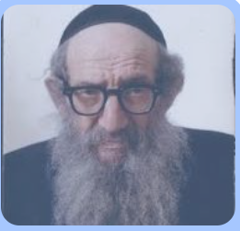

**The Sadovner Rebbe, zt”l**

With those words, the Rav headed out the door, accompanied by his sons. They arrived at the man’s house, and Rav Sekula asked. “Did you lose any money today?”

Taken aback, the man replied that he had lost a one-hundred-dollar bill somewhere. Rav Sekula said, “Did you intend to give me ten dollars this morning?” When the man replied that he did, the Sadovner Rav handed him the one-hundred-dollar bill and explained what had happened.

However, the man was somewhat embarrassed to accept the money and said that the Sadovner Rav should keep it. However, Rav Sekula wouldn’t hear of it. He said, “I only accept Tzedakah that is given B’Leiv Shamleim, with a full heart. You never intended to give this for Tzedakah. Please take back your one hundred dollars, give me ten dollars, and all will be good.”

When this was finished, Rav Sekula wished him a Freilichin Purim, and headed home with his children to have his Purim Seudah!

*Reprinted from the Parashas Tetzaveh-Purim 5785 email of Rabbi Yehuda Winzelberg’s Torah U’Tefilah.*